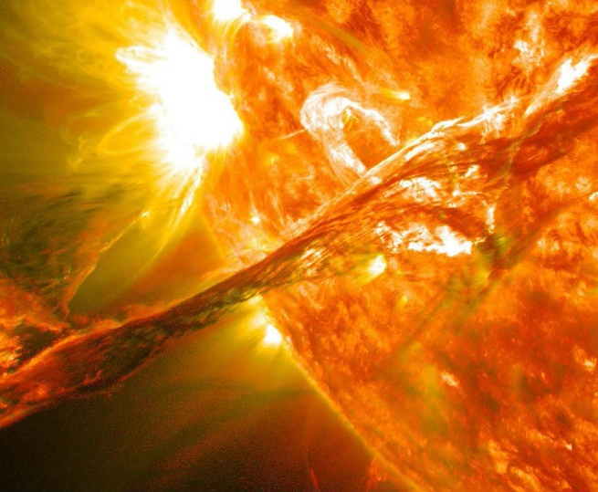
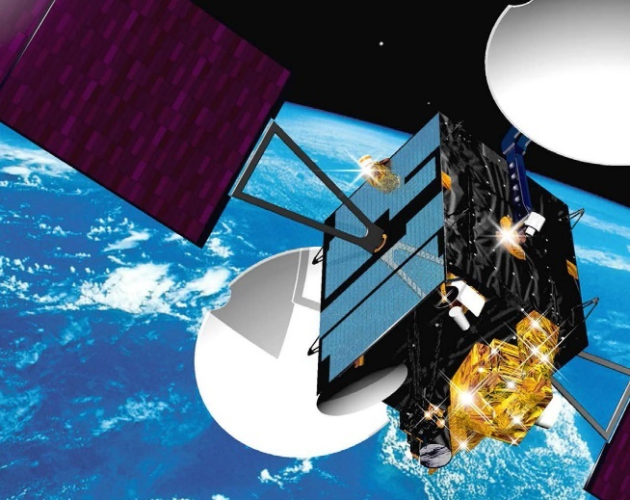

Fast forward to a future solar max – a time when the greatest solar activity in the 11 year solar cycle of the sun takes place. A major coronal mass ejection (CME) occurred just four weeks ago, with a burst of solar winds blasting from the sun toward Earth. The threat caused an immediate evacuation of the Space Station to ensure the safety of our astronauts in low Earth orbit. Fortunately, the Space Station was unharmed, but some satellites were not as lucky. The strength of the CME was so strong that several vital satellites, responsible for collecting Earth science information, suffered critical damage.
Without these satellites we can no longer identify and study the changes that are occurring on our planet. While heading back into orbit during this turbulent time of solar activity is a risk, there is no choice. The destruction caused by the CME must be addressed immediately.
It will take a true team effort of scientists from the Mission Control crew and astronauts in the Space Station to fix this serious problem. The two groups will have to quickly address the damage and achieve two major goals: Use their location in space and the instruments on the Space Station to observe the Earth and its changes and utilize the small manufacturing facility on the Space Station to create a new micro satellite to replace the one lost in the CME.

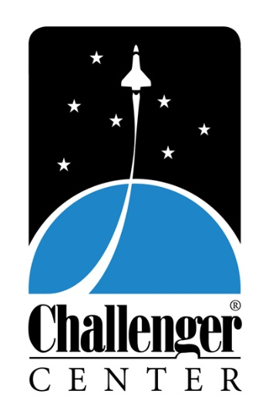
Earth Odyssey brings Earth Science to life, giving students the exciting opportunity to apply what they learn in the classroom to a real life scenario in our state-of-the-art simulated learning environment.

MISSION TEAMS
One member of each team will be in Mission Control for the first half of the mission while the other is assigned to the Space Station. Half way through Lunar Quest, the group in Mission Control launches to the Space Station and the Space Station group returns to work in Mission Control
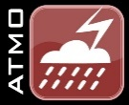
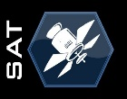
Before the mission begins, educators have access to a teacher guide developed to give students an understanding of topics covered in the mission. Lesson plans and activities are outlined to correspond with four key areas – The Importance of the Sun, The Earth’s Atmosphere and Carbon Dioxide, The Water Cycle, and Remote Sensing Communications.
COMMUNICATION (COM)
Provide communications support between astronauts and Mission Control; Manage the distribution of assignments during an event and during some emergencies; Provide critical satellite launch information.
SATELLITE (SAT)
Monitor the Earth Observation Satellite network; Build and test a remotely operated satellite to study Earth, installing critical equipment and components and retrieving data.
BIOSPHERE (BIO)
Study the impact of Earth’s vegetation and photosynthesis on CO2 and climate change; Observe population parameters and their environmental effects.
ATMOSPHERE (ATMO)
Examine the effect of greenhouse gases on global temperature; Study precipitation, cloud cover and atmospheric aerosols.
GEOSPHERE (GEO)
Observe ways in which land use and vegetation affect the carbon cycle and the greenhouse effect.
OCEAN
Research how changes in temperature and CO2 in the atmosphere affect biological and physical properties of the ocean.
SPACE WEATHER (SW)
Examine sun spot activity, solar flares and coronal mass ejections and their effects on the Earth, satellites and the spacecraft; Handle preparations for solar flare or space debris emergencies by determining location, severity and effects.
CRYOSPHERE (CRYO)
Study snow and ice cover, reflected sunlight and temperature to see how melting glaciers and sea ice affect sea level and water supply.
ENERGY (NRG)
Study solar power, incoming and outgoing radiation from the sun, and how solar radiation affects the Earth’s global temperature.
NAVIGATION (NAV) Track satellites to ensure quality communication; Calculate and plot the course for the Spacecraft to reach and navigate on the Moon.
ASTROBIOLOGY (ASTRO) Study life as we know it and what is necessary for life to survive; Search for planets that fit the criteria necessary to sustain life as we know it.
HAZARD (HAZ) Study pH levels and air quality and their relationship with healthy living conditions for the crew; Create and design an air filter out of the materials provided.
Through both project and problem-based learning, students taking part in the mission have to complete tasks to ensure success. At the same time, they may encounter emergencies or unexpected problems that require critical thinking and decision-making skills to find resolutions. Each student plays a part in the mission, interacts with at least one physical hands-on lab, and is responsible for finishing several tasks. Teamwork is crucial because if one member of the class fails to complete his or her job, the entire mission may be at risk.
Aligned with Common Core and Next Generation Science Standards and containing up-to-date, accurate educational content, for the first time Challenger Center missions can be customized to allow for adaptations based on needs and the educational levels of the class visiting the Center. In addition, Challenger Center digital mission and data logs now provide teachers with a level of assessment for post mission review and to help continue the experience in the classroom. Teachers can walk away with a digital copy of the information students inputted during the mission to gain a better understanding of strengths and weakness of that particular class.

